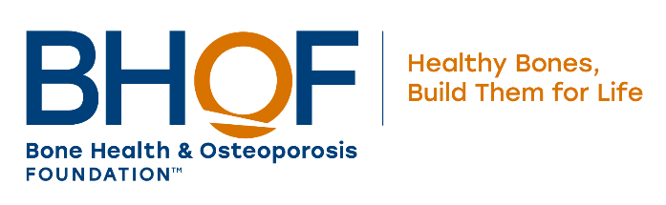

Bone Health and Osteoporosis Foundation Support Group Program “How To”

Welcome! We are grateful that you are interested in the Bone Health and Osteoporosis Foundation (BHOF) Support Group Program. BHOF is the leading consumer and community-focused health organization dedicated to the prevention of osteoporosis and broken bones, the promotion of strong bones for life and the reduction of human suffering through programs of public and clinician awareness, education, advocacy and research.

BHOF strives to assist the millions of people affected by osteoporosis by establishing a unified, national network of Support Groups that is committed to providing people with the opportunity to obtain accurate, timely information in an environment where they are both comfortable and understood. BHOF’s Support Group Program was created to assist individuals interested in starting osteoporosis Support Groups for patients, family members and friends. By joining BHOF’s network of Support Groups, you can make a difference in your community by helping those with this debilitating disease.

BHOF Support Group Benefits
- The credibility of affiliation with the Bone Health and Osteoporosis Foundation
- Referrals and publicity to generate new membership in your group
- A copy of BHOF’s comprehensive Support Group Leader Manual
- Access to cutting-edge information that has been vetted by experts in the field of osteoporosis and bone health
- A series of bi-monthly educational materials to share with your members
- Opportunity to participate in two annual conference calls and interact with BHOF’s network of Support Group leaders

Criteria for Becoming an BHOF Support Group
There is no charge to become a BHOF-affiliated Support Group. All BHOF Support Groups must:
- Have at least one Support Group leader and at least five members
- Identify a qualified healthcare professional to serve as a Medical Advisor
- At the minimum, convene four times per year

Medical Advisor Responsibilities
- Discussing and approving all meeting topics, speakers, programs and non-BHOF materials distributed at meetings
- Referring patients and others to Support Group meetings
- Serving as a liaison between the group and community contacts, such as physicians, physical therapists, dietitians, nurses, nurse practitioners, pharmacists, etc.
- Acting as the Support Group’s spokesperson with media and/or similar opportunities

BHOF Support Group Affiliation Agreement

We, the undersigned, do hereby establish our osteoporosis Support Group as an affiliate of the Bone Health and Osteoporosis Foundation and, as leader(s) of this Support Group, pledge to support the goals of BHOF primarily by:

- Providing accurate, up-to-date osteoporosis information to Support Group participants.
- Creating opportunities for affected persons to share concerns, problems and coping strategies regarding their disease management.
- Ensuring that only qualified professionals present medical information. No Support Group leader or member may give any medical advice at any time.
- Soliciting and receiving approval by the medical advisor on speakers, meeting topics and any non-BHOF materials containing medical information or including the advisor’s name.
- Keeping all personal and medical information shared at meetings confidential.
- Advising members that alternative treatments are scientifically unproven if such products are discussed.
- Responding to emails from BHOF’s Support Group coordinator and providing any requested information related to the Support Group.
- Sending newsletters, flyers, announcements, etc. to BHOF’s Support Group coordinator.
- Notifying BHOF if we disband or withdraw from BHOF’s Support Group Program.
_________________________________________________________________________________________
Support Group Leader(s) Name(s) Printed Date

_____________________________________________________________________________________
Support Group Leader(s) Signatures Date

_____________________________________________________________________________________
Medical Advisor Name Printed Date

_____________________________________________________________________________________
Medical Advisor Name Signature Date

Founding Members: Five members are needed to establish an BHOF Support Group. Please include names and addresses of your group’s members. Please note that this information will be kept confidential.

- _____________________________________________________________________________________________
- _____________________________________________________________________________________________
- _____________________________________________________________________________________________
- _____________________________________________________________________________________________
- _____________________________________________________________________________________________

Please email the completed application to Lindsey West, lwest@bonehealthandosteoporosis.org

