American Bone Health™ Virtual Programs Available in May

Founded in 1990 and the only national nonprofit dedicated to community education around bone health, American Bone Health™ is offering live, virtual programs during Osteoporosis Awareness Month to help people learn how important it is to take care of their bones and what steps they can take to help prevent fractures and osteoporosis. Register now for any or all of these evidence-based programs; then, add them to your calendar so you don’t forget to attend.

BoneSense® Speaker Series™: Osteoporosis Treatments
The American Bone Health BoneSense® Speaker Series™ highlights important topics related to bone health, engaging experts from the American Bone Health Medical and Scientific Advisory Board. This webinar, featuring Dr. Nancy E. Lane, Professor of Medicine, Rheumatology, and Aging at the University of California Davis School of Medicine, is a must-see if your health care provider has recommended medicine to protect or improve your bone health. Learn about the benefits and potential rare side effects of taking the medicines and the risks of not taking the medicines.

Monday, May 1, 2023, 7:00 pm ET
AmericanBoneHealth.org/bss0501

Healthy Bones for Life™
An American Bone Health Peer Educator will present this program, introducing the basics of bone health and why it should be important to you.

Thursday, May 11, 2023, 3:00-4:00 pm ET
AmericanBoneHealth.org/hbl0511

Beyond the Break™
Breaking a bone is a sentinel event and a critical indicator that bones may be weak, and there is an increased risk of future broken bones. An American Bone Health Peer Educator will explain how to manage your risk to prevent more broken bones.

Thursday, May 18, 2023, 1:00-2:00 pm ET
AmericanBoneHealth.org/btb0518

Freedom From Fractures™
An American Bone Health Peer Educator will share how medicines, medical conditions and family history can affect the risk of fractures and what to do to prevent them.

Wednesday, May 24, 2023, 1:00-2:00 pm ET
AmericanBoneHealth.org/fff0524

Graphics, captions and hashtags for bone health tips for Partner to share via social media channels

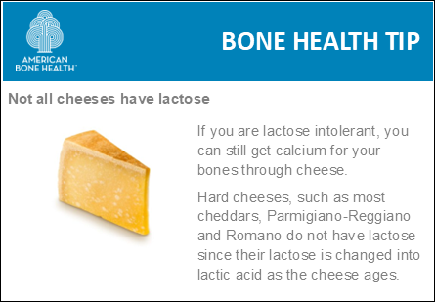

One food strategy for reducing symptoms of lactose intolerance is to get into the habit of adding small portions of grated hard cheese to your soups, pastas, salads, grilled vegetables, omelets, etc. For more tips on lactose intolerance, visit https://americanbonehealth.org/nutrition/tips-for-lactose-intolerance/

#osteoporosisawarenessmonth
#lactoseintolerance
#bonehealth
#americanbonehealth
#osteoporosis

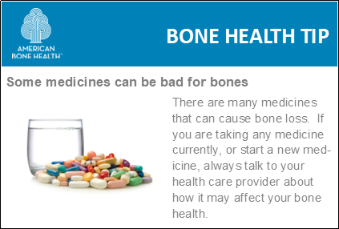

Click here to see a list of medicines that can be bad for bone health, https://americanbonehealth.org/bone-health/medications-that-can-be-bad-for-your-bones-2/

#osteoporosisawarenessmonth
#bonehealth
#americanbonehealth
#osteoporosis

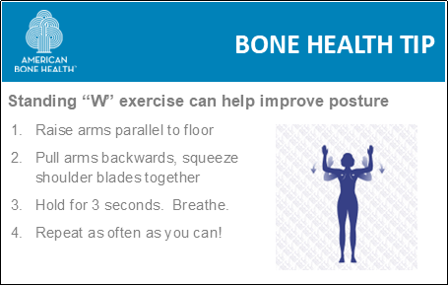
Improving your posture, strength and balance can help prevent falls and fractures. Try to incorporate something into your daily routine. For more exercises, visit https://americanbonehealth.org/exercises/

#osteoporosisawarenessmonth
#bonehealth
#americanbonehealth
#osteoporosis
#fallprevention
#posture

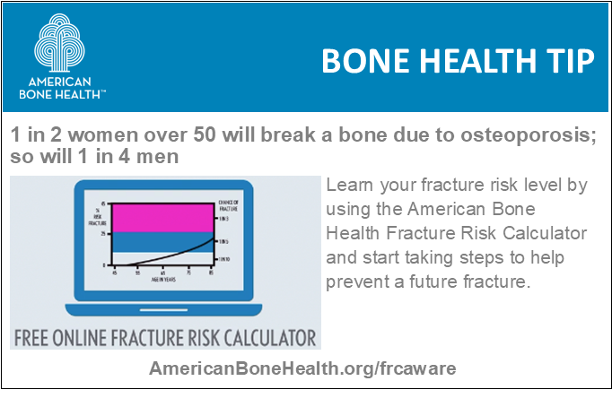

Osteoporosis is known as the “silent” disease, because people don’t realize their bones are weak until they break a bone. It’s possible you may be at an elevated fracture risk level. Use the American Bone Health Fracture Risk Calculator™ today to learn about your fracture risk level. https://americanbonehealth.org/frcaware

#osteoporosisawarenessmonth
#bonehealth
#americanbonehealth
#osteoporosis
#fracturerisk
#fractureriskcalculator
#fractureprevention

