Join the Bone Health & Osteoporosis Foundation (BHOF) in raising awareness about bone health and osteoporosis during Osteoporosis Awareness and Prevention Month in May!

Osteoporosis is a common condition that affects millions of people worldwide. In fact, approximately 54 million Americans have low bone density or osteoporosis. It is a progressive disease that weakens bones, making them more fragile and susceptible to fractures. Osteoporosis Awareness and Prevention Month is observed every May to educate people about bone health and the importance of taking preventative measures.

This toolkit provides a collection of social media posts and graphics that you can use to help raise awareness. By using these resources to spread the word about osteoporosis, we can help prevent this disease from taking a toll on people's lives. Let’s work together to promote good bone health and prevent serious broken bones!

Click here to visit the Osteoporosis Awareness and Prevention Month page.

Help us spread the word!

Tag BHOF in your posts so we can share/amplify!

Facebook: @bonehealthandosteoporosisfoundation
Twitter: @bonehealthBHOF
LinkedIn: @bonehealthandosteoporosis
Instagram: @bonehealthandosteoporosis

Use the following hashtags:

#OsteoporosisAwareness
#OAPM2023
#BeBoneStrong

Additional tips:
- Personalize posts or copy and paste the suggested text we’ve provided.
- Encourage your social media followers to get involved and spread the word!
- Share and repost BHOF content throughout the month.

Don’t miss these items and events! In addition to the suggested social media posts, you can share info about these initiatives as well:
- Free Webinars
- Bone Talk Podcast
- Support Groups
- Your Path to Good Bone Health (new online tool)
- Informational Resources and Guides
- Patient Registry

Suggested Social Media Posts

Click here to download a zipped folder of the accompanying graphics.

May is Osteoporosis Awareness and Prevention Month! Help me raise awareness and get involved by visiting https://www.bonehealthandosteoporosis.org/awareness-month! #OsteoporosisAwareness #BeBoneStrong #OAPM2023
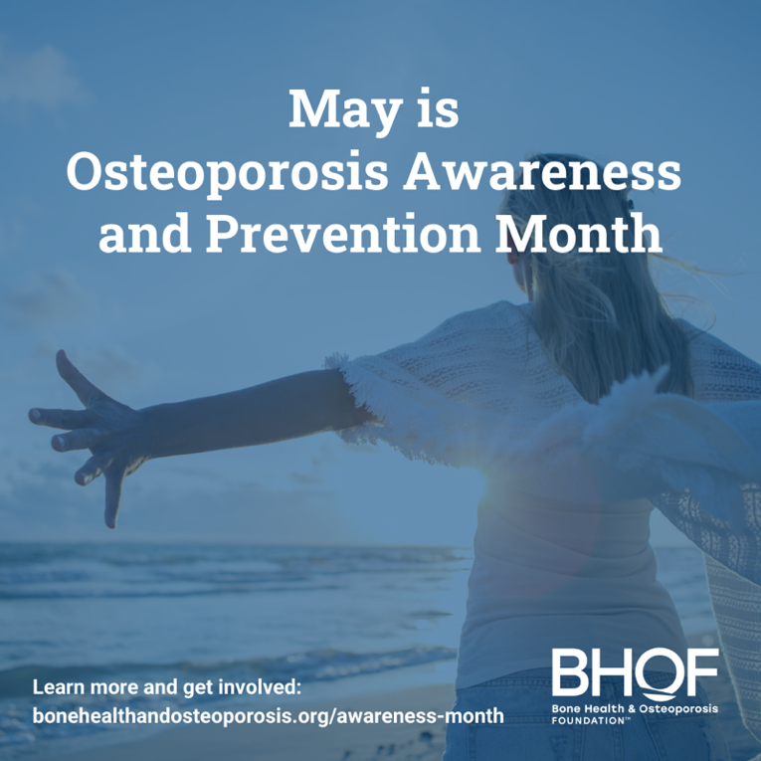

Osteoporosis is called a silent disease because it often progresses without symptoms until a fracture occurs. Join me in raising awareness about osteoporosis this May during Osteoporosis Awareness and Prevention Month! https://www.bonehealthandosteoporosis.org/awareness-month! #BeBoneStrong #OAPM2023 #OsteoporosisAwareness
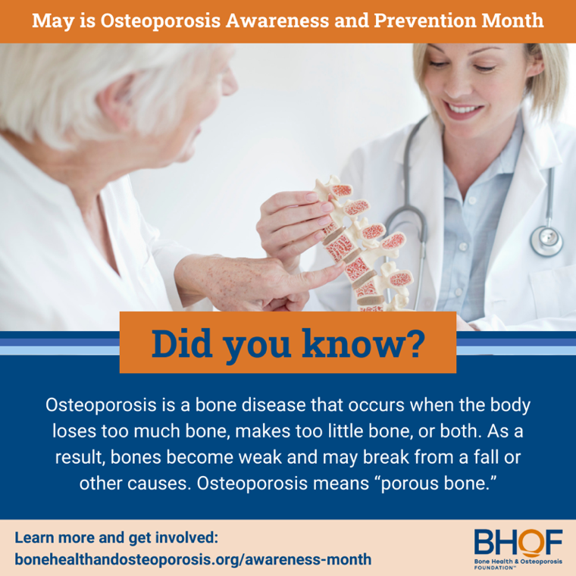

Children and young adults who have higher peak bone mass reduce their risk of osteoporosis later in life.
Learn more and help spread awareness about bone health: https://www.bonehealthandosteoporosis.org/awareness-month #OsteoporosisAwareness #BeBoneStrong #OAPM2023
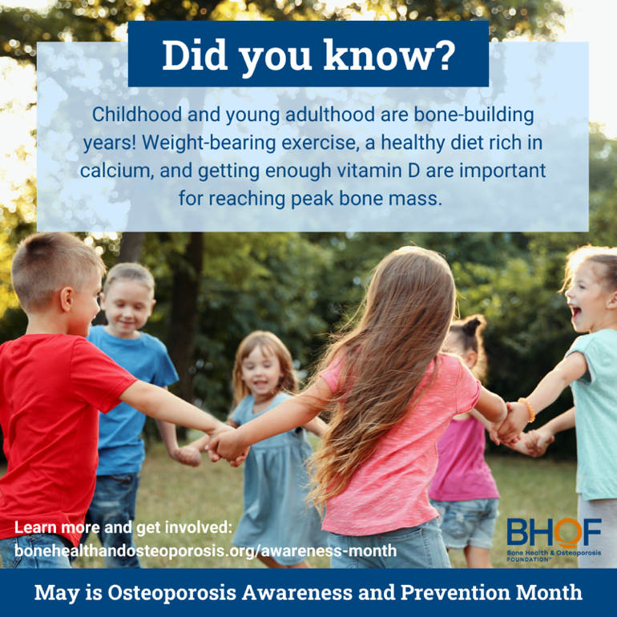

Osteoporosis is not just a women’s disease! In fact, 1 in 4 men over age 50 will experience an osteoporotic fracture in their lifetime. Learn more and find resources to promote bone health during May’s Osteoporosis Awareness and Prevention Month: https://www.bonehealthandosteoporosis.org/awareness-month #BeBoneStrong #OAPM2023 #OsteoporosisAwareness
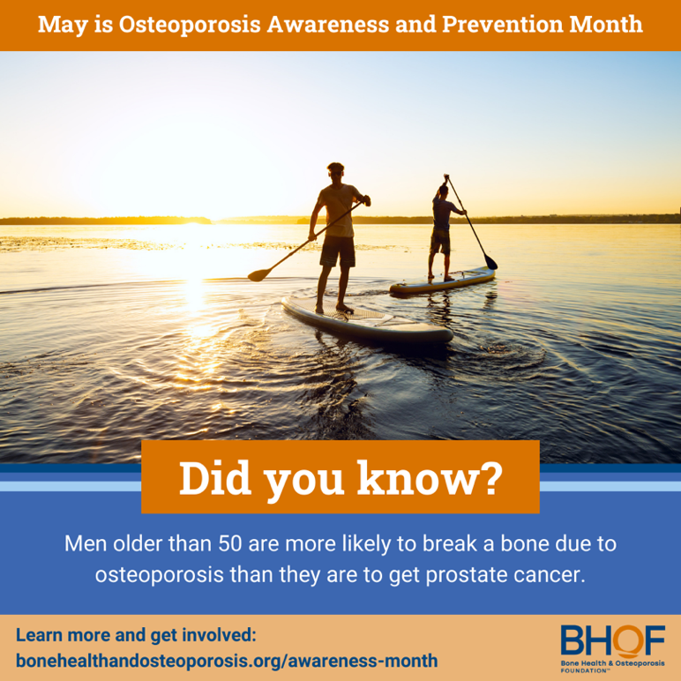

Menopause can increase the risk of osteoporosis due to decreased estrogen levels. Learn more and find resources to promote bone health during May’s Osteoporosis Awareness and Prevention Month: https://www.bonehealthandosteoporosis.org/awareness-month #BeBoneStrong #OAPM2023 #OsteoporosisAwareness
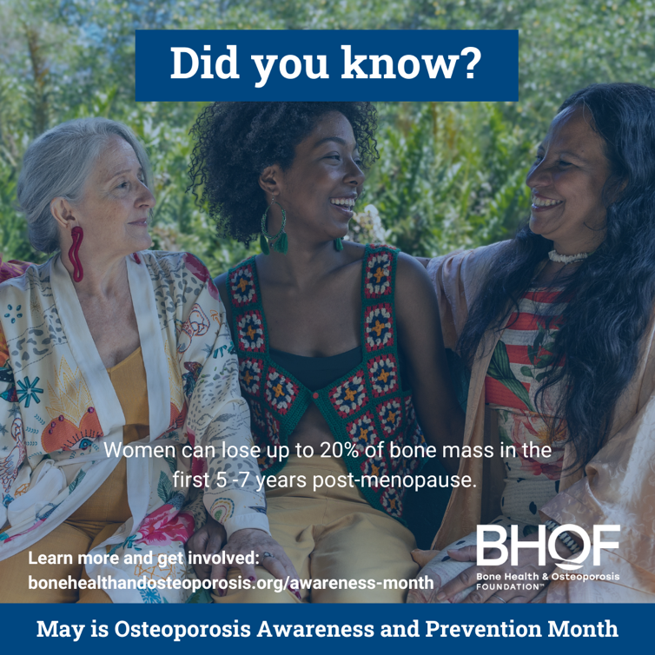

It's so important to prioritize our bone health from a young age! One way to do that is by ensuring we get enough calcium and vitamin D. Learn more and help spread awareness about bone health: https://www.bonehealthandosteoporosis.org/awareness-month #OsteoporosisAwareness #BeBoneStrong #OAPM2023
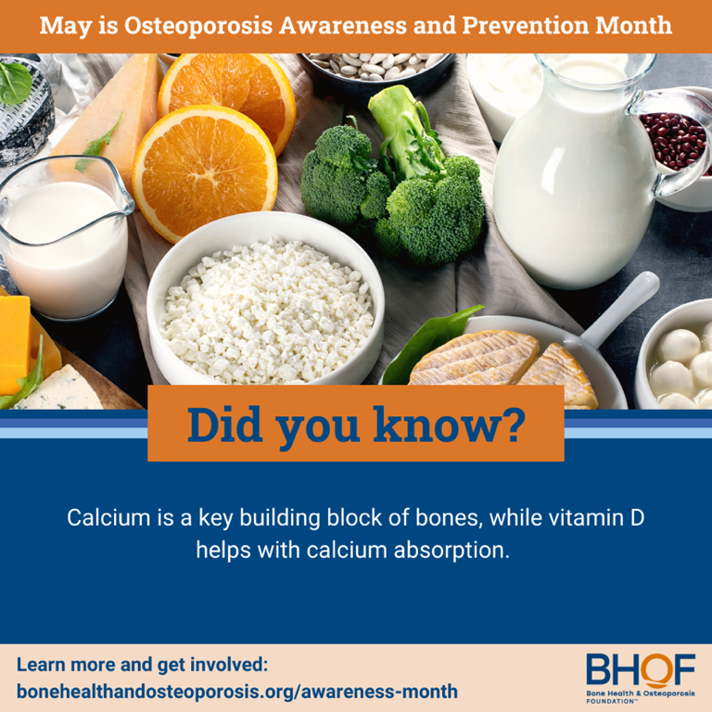

Strong bones are the foundation of a healthy and active lifestyle! Let's give our bones the support they need to help keep us moving and grooving! Learn more and find resources to promote bone health during May’s Osteoporosis Awareness and Prevention Month: https://www.bonehealthandosteoporosis.org/awareness-month #BeBoneStrong #OAPM2023 #OsteoporosisAwareness
